1 : What is Tableau? Explain its importance in Business Intelligence and how it helps in data-driven decision-making.

Tableau is a business intelligence (BI) and data visualization tool that transforms raw data into interactive and easily understandable dashboards, charts, and reports. Its importance in BI is that it makes complex data accessible to users, regardless of technical skill, enabling faster and more informed decision-making. It helps drive data-driven decisions by allowing users to explore data, identify trends, and spot outliers visually to create data-backed strategies.
Importance in Business Intelligence
- Data accessibility: Tableau democratizes data analysis, allowing both technical and non-technical users to explore and find insights through a user-friendly interface.
- Data transformation: It converts large, complex datasets from various sources like spreadsheets and cloud databases into clear, visual formats.
- Interactive dashboards: It provides a platform for creating interactive dashboards and reports that offer a real-time view of key performance indicators (KPIs) and business performance.
How it helps in data-driven decision-making
- Reveals trends and patterns: By visualizing data, users can easily spot trends, patterns, and outliers that might be missed in raw data, such as identifying seasonal sales trends across different regions.
- Enables quicker analysis: It allows for faster, more efficient data analysis, enabling businesses to react to changes and opportunities in near real-time.
- Supports a collaborative culture: By making data insights accessible to more people, Tableau encourages collaboration and strengthens a data-centric culture across different departments.
- Informs strategy: It helps leadership and teams formulate data-backed strategies by providing a clear, visual basis for decisions related to everything from marketing campaigns to supply chain efficiency and retail profitability.
2 : Explain the role of the following Tableau components: a) Data Pane b) Worksheet c) Dashboard d) Story

In Tableau, each component serves a distinct purpose in visualizing and presenting data:
- Data Pane: This is where you access and manage the data from your source. It displays all the fields in your dataset, categorized as measures (numerical values) and dimensions (categorical values). You use the Data Pane to drag and drop fields onto shelves within your visualizations.
- Worksheet: A worksheet is a single view within a Tableau workbook. It contains a chart, graph, or table based on the data selected from the Data Pane. You can add filters, axes, labels, and other elements to customize your visualization within a worksheet.
- Dashboard: A dashboard is a collection of multiple worksheets combined into a single, unified view. Dashboards allow you to present different aspects of your data simultaneously, providing a holistic overview. They can be interactive, enabling users to drill down into specific data points by clicking on elements within the visualization.
- Story: A story is a sequence of worksheets and dashboards that tell a narrative with your data. Stories provide a structured way to present complex information, highlight key insights, and guide the viewer through a logical progression of analysis.
3 : What is the difference between Dimensions and Measures in Tableau? Provide examples of each.

In Tableau, Dimensions are qualitative, categorical data used for grouping and context (like product name or date), while Measures are quantitative, numerical data used for calculations and aggregations (like sales or profit). Dimensions are used to define the "what" or "by what" in a visualization, creating headers and axes, whereas measures answer "how much" or "how many," and are the values plotted on charts.
Feature | Dimensions | Measures
Data Type | Qualitative/Categorical (e.g., text, dates) | Quantitative/Numerical (e.g., numbers)
Role | Provide context and define the level of detail | Provide the values for calculation and analysis
Aggregation | Not aggregated by default; they define the grouping | Aggregated by default (e.g., SUM, AVG, COUNT)
Examples | Product Category, Customer Name, Order Date | Sales, Profit, Quantity Sold
Visualization | Often appear as headers, defining the rows and columns | Often appear as the values that create the bars, lines, or points
Example Scenario
Imagine a dataset with sales information.
- Dimensions: Product Name, Customer Region, and Order Date would be dimensions. These would be used to group the data, so you can see a breakdown of sales by each region, or how sales changed over the months.
- Measures: Sales and Profit would be measures. You would use them with the dimensions to calculate the total sales for each region, the average profit per order, or the total profit for the entire dataset.
4 : Define and explain the purpose of Filters, Parameters, and Sets in Tableau.

Filters narrow a dataset to a specific view by removing rows of data, while Parameters allow users to control values in calculations or filters dynamically and can be used across a workbook. Sets create a subset of data based on a condition that can be used for comparisons, as filters, or to add a new dimension to the view.
Filters
- Definition: A filter is a tool to limit the data that appears in a worksheet or dashboard, based on a condition.
- Purpose: To reduce the number of records and focus the analysis on relevant information. For example, you might use a filter to show sales only for a specific region or a particular time period.
- Key Characteristics:
  - By default, filters apply only to the worksheet they are created on.
  - Filters can be based on dimensions, measures, or dates.
  - A single filter can affect multiple worksheets if applied across related data sources.
Parameters
- Definition: A parameter is a user-defined variable that can be a number, date, or string, which can be used to replace a constant in calculations, filters, or reference lines.
- Purpose: To allow users to interact with a view and dynamically change its behavior. For instance, a parameter can let a user select the number of "Top N" items to display, or change the threshold for a calculated field.
- Key Characteristics:
  - Parameters can be single-select and are independent of the data source.
  - They can be used in calculated fields and reference lines.
  - A parameter's scope is the entire workbook, making it visible and usable across all worksheets.
Sets
- Definition: A set is a named collection of data members that meet certain criteria.
- Purpose: To create a more permanent and reusable subset of data. Sets are often used for comparison (e.g., comparing the top performers against the rest of the group) or to add a new dimension to a visualization.
- Key Characteristics:
  - Sets can be used as filters by dragging them to the Filters shelf.
  - They are more permanent and reusable across the entire workbook, similar to parameters.
  - Sets can also be used in calculations and can add a new, discrete dimension to a view.
5 : Create a bar chart showing Gross Sales by Country. ● Sort the countries in descending order of sales ● Highlight or annotate the bar that represents the maximum and minimum Gross Sales. ● Add data labels and format the chart for presentation.

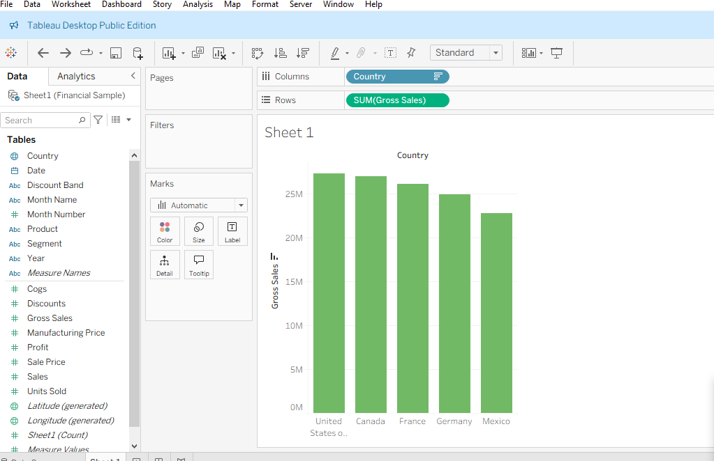

6 : Using Tableau, create a dual-axis chart that displays: ● Monthly Sales as bars ● Monthly Profit as a line ● Filter the data to include only records from the year 2014 ● Ensure both axes are synchronized and properly labeled ● Add an appropriate chart title, and format the chart for clear visual presentation ● Paste a screenshot of the final chart in your submission

1. Connect to Your Data
- Open Tableau Desktop.
- Connect to your dataset (e.g., Sample - Superstore or your own sales data).

2. Set Up the View
- Drag Order Date (or your date field) to the Columns shelf.
- Right-click on it → Select “Month” (not continuous green pill, but discrete blue “Month”).
- Drag Sales to the Rows shelf.
You’ll now see monthly sales bars.

3. Add Profit as a Dual Axis
- Drag Profit to the Rows shelf and drop it to the right of the Sales axis (so you get a second axis).
- Tableau will create a dual-axis chart.

4. Change the Chart Type for Profit
- Click the Marks dropdown for each axis:
  - For SUM(Sales) → choose Bar.
  - For SUM(Profit) → choose Line.

5. Filter for the Year 2014
- Drag Order Date again to the Filters shelf.
- In the filter dialog, select Years, click Next, then choose 2014.
Now your chart only displays 2014 data.

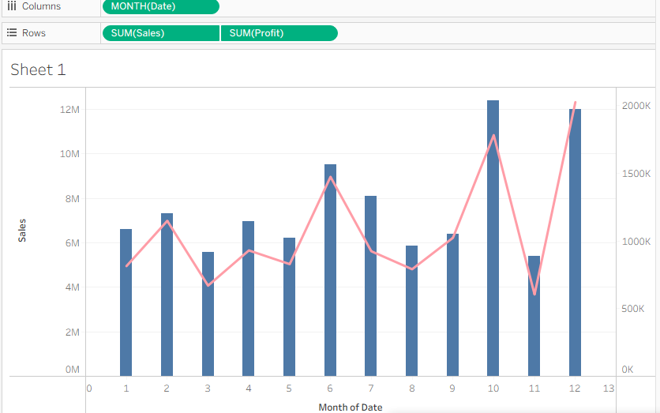

7 : Create a filled map showing total Units Sold by Country. ● Add a parameter to allow users to switch between Units Sold and Profit. ● Use the Discount Band as a filter in your visualization.

Steps to Create the Filled Map in Tableau

1. Connect your data
Make sure your dataset includes at least these fields:
- Country
- Units Sold
- Profit
- Discount Band

2. Create a Parameter
We’ll create a parameter to toggle between “Units Sold” and “Profit.”
- In the Data Pane, right-click → Create Parameter
- Name it: Measure Selector
- Set:
  - Data type: String
  - Allowable values: List
  - Add two values:
    - "Units Sold"
    - "Profit"
- Click OK
- Right-click the parameter and choose Show Parameter Control

3. Create a Calculated Field to Use the Parameter
- Right-click in the Data Pane → Create Calculated Field
- Name it: Selected Measure
Formula:
CASE [Measure Selector]
WHEN "Units Sold" THEN [Units Sold]
WHEN "Profit" THEN [Profit]
END

- Click OK

4. Create the Filled Map
- Drag Country to Detail (on the Marks card)
- Change the Mark type to Map
- Drag your new field [Selected Measure] to Color
- Tableau will automatically color each country based on the selected measure.

5. Add the Discount Band Filter
- Drag Discount Band to the Filters shelf.
- Choose which Discount Bands to display (or allow users to choose all).
- Right-click the filter → Show Filter so users can interact with it.
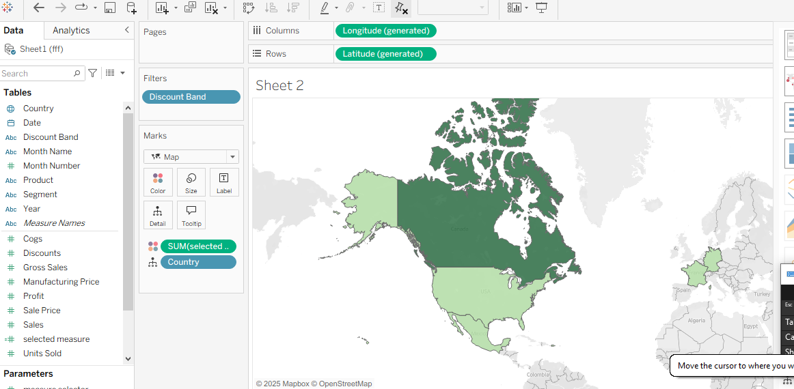

8 : Create a dashboard that includes: ● KPI tiles for Total Sales, Total Profit, and Total Units Sold ● A line chart for Profit trend over time ● Filters for Product and Country Ensure your dashboard is interactive and visually appealing.

Step 1: Connect and Prepare Your Data
- Open Tableau Desktop or Tableau Public.
- Connect to your data source (e.g., Excel, CSV, SQL).
  - Your dataset should include at least these fields:
    - Order Date (or Date)
    - Sales
    - Profit
    - Units Sold
    - Product
    - Country
- Go to the Data Source tab and make sure data types are correct:
  - Date → Date
  - Sales/Profit/Units → Number (decimal or integer)

📊 Step 2: Create KPI Tiles
You’ll make three separate sheets—one for each KPI.

1. Total Sales
- Go to a new sheet → Name it “KPI – Total Sales”.
- Drag Sales to Text (on Marks card).
- Change aggregation to SUM(Sales).
- Format it (e.g., currency, large font, centered).
- Optionally add a background color via Format → Shading.

2. Total Profit
- Duplicate the Sales KPI sheet.
- Replace SUM(Sales) with SUM(Profit).
- Rename to “KPI – Total Profit”.
- Change color scheme to something that distinguishes it.

3. Total Units Sold
- Duplicate again.
- Replace the measure with SUM(Units Sold).
- Rename to “KPI – Units Sold”.

📈 Step 3: Create Profit Trend Over Time Chart
- Create a new sheet → Name it “Profit Trend”.
- Drag Order Date (or Date) to Columns.
- Drag Profit to Rows.
- Change Order Date to a continuous month or quarter (right-click → "Exact Date" or "Month").
- Convert the chart to a line chart (on Marks card → Line).
- Add Country or Product to Color for breakdowns if you like.
- Format axes and titles neatly.

🎛 Step 4: Add Filters for Product and Country
- In the Profit Trend sheet (or any), drag Product and Country to the Filters shelf.
- Right-click each field → Show Filter.
- Format them as dropdown or multi-select filters.

🧠 Step 5: Build the Dashboard
- Click the “New Dashboard” button at the bottom tab bar.
- Set dashboard size (e.g., 1200x800 for a desktop view).
- Drag in the following sheets:
  - The three KPI tiles at the top (arranged horizontally)
  - The Profit Trend chart below them
- Add Product and Country filters to the right or top.
  - Use “Apply to all using this data source” to make filters global.
- Use containers for clean layout:
  - Horizontal container for KPIs
  - Vertical container for overall structure

🎨 Step 6: Style and Polish
- Titles: Add clear titles like “Sales Performance Dashboard”.
- Colors: Use a consistent color palette (e.g., blues for sales, greens for profit).
- Fonts: Use bold fonts for KPIs, legible fonts for charts.
- Tooltips: Customize to show key info like Sales, Profit, and Date.
- Interactivity: Enable “Use as Filter” on the Profit Trend if you want to drill down.
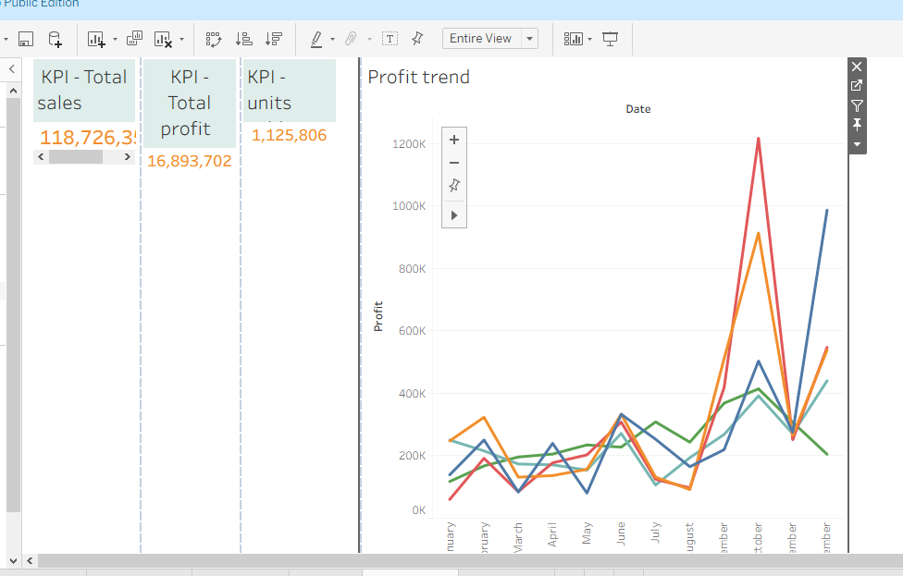

9 : Your goal is to identify products that generate low profit despite high sales volume. ● Use scatter plot or highlight table to identify such products. ● Add filters for Country and Segment. ● Write two business insights based on your chart.

Option A: Scatter Plot
- X-axis: Sales (or Sales Volume)
- Y-axis: Profit
- Each point: A product
- Color: Segment (e.g., Consumer, Corporate, Home Office)
- Size: Quantity Sold (optional)
- Filters:
  - Country
  - Segment
This lets you quickly spot products that fall far right (high sales) but low or negative on Y-axis (low profit).
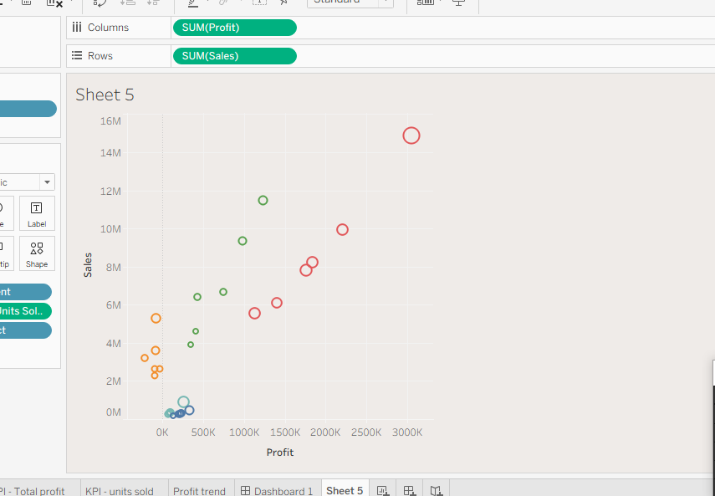

Question 10 : [Scenario-Based – Customer Behavior & Retention Strategy] Dataset Name: Online Retail II Dataset Source: UCI Machine Learning Repository – Online Retail II Dataset Business Scenario: You are a Data Analyst at an e-commerce company that sells home decor and gifts across multiple countries. The leadership team is concerned about customer churn and revenue loss due to inconsistent customer behavior. They’ve asked you to investigate patterns in customer orders, returns, and geographic sales performance from the Online Retail II dataset.Your Task in Tableau: 1. Use Tableau to answer these questions: ○ Which countries have the highest number of repeat customers? ○ What is the return rate by product and Find top 10 countries? ○ What time of year do customers tend to buy the most (Seasonality) ? ○ Are there certain customers with high order value but also high return rates? 2. Create visualizations: ○ A map showing Revenue by Country ○ A line chart of Monthly Sales Trend ○ A bar chart showing Top 10 customers by Total Revenue ○ A table/heatmap showing Top returned products by country 3. Build a dashboard for business insights: ○ Allow filters for Country, Product, and Customer ID ○ Use KPIs for: ■ Total Revenue ■ Total Returns ■ Repeat Customer Count 4. Write a short business insight (2–3 sentences): Based on your Tableau dashboard, what recommendations would you make to help reduce churn and increase customer loyalty?

Q1. Which countries have the highest number of repeat customers?
- How to find it:
  - Create a calculated field:
Repeat Customer = IF [Number of Orders] > 1 THEN "Yes" ELSE "No" END
  - Use a COUNTD([Customer ID]) filtered to "Repeat Customer" = Yes by Country.
  - Sort descending to find top countries.
- Visualization: Bar chart (Country vs. Repeat Customer Count).

Q2. What is the return rate by product and find top 10 countries?
- How to find it:
  - Create calculated fields:
    - Return Rate = SUM([Returned Orders]) / SUM([Total Orders])
  - Show Return Rate by Product and Country.
  - Sort and filter for the top 10 countries by return rate.
- Visualization: Heatmap or bar chart (Product vs. Country, colored by Return Rate).

Q3. What time of year do customers tend to buy the most (Seasonality)?
- How to find it:
  - Create a line chart using Order Date (month) on the X-axis and SUM(Sales) on the Y-axis.
  - Use the MONTH(Order Date) or DATETRUNC('month', [Order Date]) function.
- Visualization: Line chart showing Monthly Sales Trend.

Q4. Are there customers with high order value but also high return rates?
- How to find it:
  - Calculate:
    - Total Order Value = SUM([Sales])
    - Return Rate = SUM([Returned Orders]) / SUM([Total Orders])
  - Plot these in a scatter plot (X-axis: Total Order Value, Y-axis: Return Rate).
  - Highlight customers in the top-right quadrant (high value & high returns).

2. Create Visualizations
Visualization | Description
Map | Revenue by Country using filled map (Color intensity = SUM(Sales))
Line Chart | Monthly Sales Trend showing seasonality
Bar Chart | Top 10 Customers by Total Revenue
Heatmap/Table | Top Returned Products by Country (color-coded by Return Rate)

3. Build a Dashboard for Business Insights

Dashboard Components
- Filters: Country, Product, Customer ID
- KPIs (cards):
  - Total Revenue: SUM(Sales)
  - Total Returns: SUM(Returned Orders)
  - Repeat Customer Count: COUNTD(Customer ID) where [Repeat Customer] = "Yes"

Design Tips
- Use a consistent color palette (e.g., blue for sales, red for returns).
- Arrange KPIs at the top.
- Place interactive filters on the right or top bar.
- Use tooltips to show extra details (e.g., country name, return %, average order size).

4. Business Insights (2–3 Sentences)
Example Insight:
Based on the dashboard, countries like the USA and Germany have the highest number of repeat customers, indicating strong brand loyalty. However, products such as Product X and Product Y show higher return rates, especially in Canada and the UK. To reduce churn, focus on improving product quality and setting clearer expectations, while offering loyalty rewards to repeat buyers to increase long-term retention.

